Team of doctors from abroad, are working together to better serve patients with Rheumatoid based diseases (Collagen diseases) from medical and surgical point of view and also give a complete evaluation and appropriate treatment in patients at high risk of osteoporosis. After 25 years in Johannesburg they have returned to Cyprus 5 years ago and now for the last one year have organized the joint clinic
CLINIC OF REYMATOLOGY AND ORTHOPAEDICS & OSTEOPOROSIS CLINIC

Doctor Nedi Zannettou, specialist physician and Specialist rheumatologist in South Africa. She did her specialization at the University of Witwatersrand - specialist physician 5 years and then in Rheumatology for another four years with all the required examinations. After that she worked in Academic Hospital as Consultant and Lecturer for medical students and Registrars in internal medicine and Rheumatology for another 10 years. She was for 8 years-second in charge - in the Rheumatology clinic of the academic hospital. After this she went full time in the private sector Hospital in Johannesburg in South Africa. At the same time, she was seriously involved with the diagnosis, evaluation and treatment of osteoporosis. To add on the above she has got the Greek General medical exams, the specialist Physician exams and the Specialist Rheumatology exams for full recognition of her diplomas in Greece.
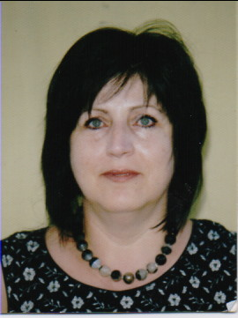
Dr Nedi Zannettou
Specialist Rheumatologist ; Specialist Physician South Africa.

Lecturer – University of Witwatersrand Johannesburg

Dr Stelios Hadjichristofis - FCS(SA)Orth. / MMed(WITS)Orth., did his specialization at the University of Witwatersrand in Johannesburg in South Africa, one of the best medical schools in the world at the time. After the completion of his specialty he wrote his thesis for his Master Degree, entitled: "The Prevalence of Osteoporosis in Primary osteoarthritis. Practical and theoretical significance."
He was an active participant for 8 years in the combined Rheumatology clinic (rheumatologists, orthopedists, physiotherapists, social workers, etc.) for an effort for the best possible outcome of these cases. After the acquisition of an extremely difficult specialty he was Consultant and head of the knee and Arthroscopy Department in the Academic Hospital where he worked for the next 5 years. After that he went to the private sector where he worked for 12 years at two Private hospitals, one of the largest hospitals in Africa. Along with the expertise and his thesis he followed all developments and progress in orthopaedics, he took the diploma ATLS (Advanced Trauma Life Support), he got a diploma for Research, he took a diploma in Robotic knee arthroplasty and he did Total Knee Replacements with robotic techniques for 8 years. He also worked extensively in surgery of the hand and foot – a big part and problem in the pathology of rheumatic diseases.
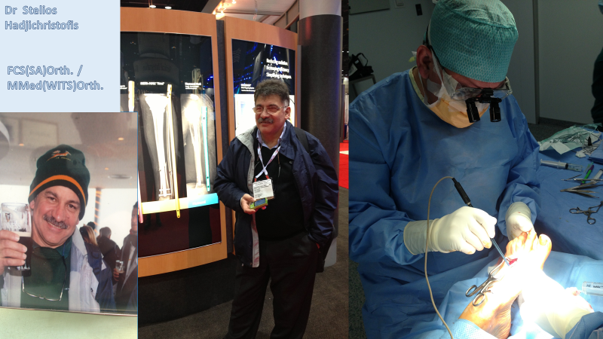
Dr Hadjichristofis Stelios FCS(SA)Orth. / MMed(WITS)Orth.
Orthopaedic Surgeon.
Master degree:
“ The Prevalence of Osteoporosis in Primary osteoarthritis. Practical and theoretical significance.”
In Apollonion Hospital is available the new machine – latest technology for measurement of the bone density – HOLOGIG DEXA.
You are welcome for complete professional diagnosis, assessment, care, treatment based on the latest developments in the field of Rheumatology and Osteoporosis. All your questions can be resolved. All plans that puzzle you, can be explained. We are looking for the best practical solution to be be applied.

===================================================================================
CLINIC OF REYMATOLOGY AND ORTHOPAEDICS & OSTEOPOROSIS CLINIC
Dr Nedi Zannettou (Rheumatologist) / Dr Hadjichristofis (Orthopaedic Surgeon)

American Medical Center Room 105, 00357 99656681
e-mail: nedihadji@cytanet.com.cy / hadjichristofis.stelios@cytanet.com.cy

